**API in NodeJs**

Create a class "Fruit" with the following fields: id, name, color

class Fruit {

constructor(id, name, color) {

this.id = id;

this.name = name;

this.color = color;

}

introduction() {

return `My id is ${id} and name is ${name} and My color is ${color}!`;

}

}

let ankit = new Fruit(1, "BANANA", "Yellow");

console.log(ankit.introduction());

let puja = new Fruit(2, "MANGO", "Yellow");

console.log(puja.introduction());

OUTPUT:-

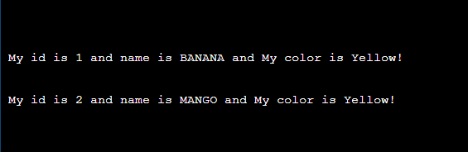

Create an API that will return a sorted List of "Fruit" objects based on color

const list = [

{ color: 'RED' , name: 'APPLE' },

{ color: 'Yellow', name: 'BANANA'},

{ color: 'Yellow', name: 'MANGO' },

{ color: 'Yellow', name: 'GRAPES' }

]

var sortedArray = list.sort((a, b) => (a.color > b.color) ? 1 : -1)

OUTPUT :

